Laporan Praktikum 6  
Praktikum Analisis Algoritma



Imron Madani (140810170061)

Fakultas Matematika dan Ilmu Pengetahuan Alam  
Program Studi Teknik Informatika  
Universitas Padjajaran  
2019

**Tugas 6 – Minimum Spanning Tree**

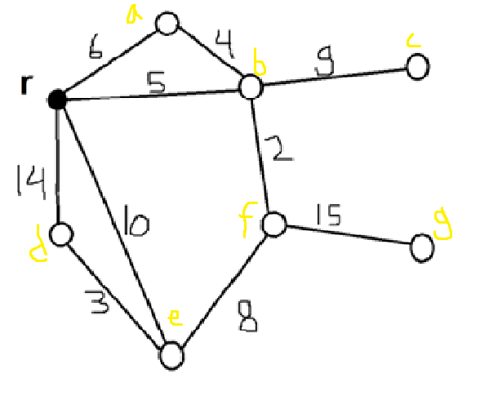

|  |  |  |
| --- | --- | --- |
| Steps | Edges | Weight |
| 1 | r-b | 5 |
| 2 | b-f | 2 |
| 3 | b-a | 4 |
| 4 | f-e | 8 |
| 5 | e-d | 3 |
| 6 | b-c | 9 |
| 7 | f-g | 15 |

PRIM

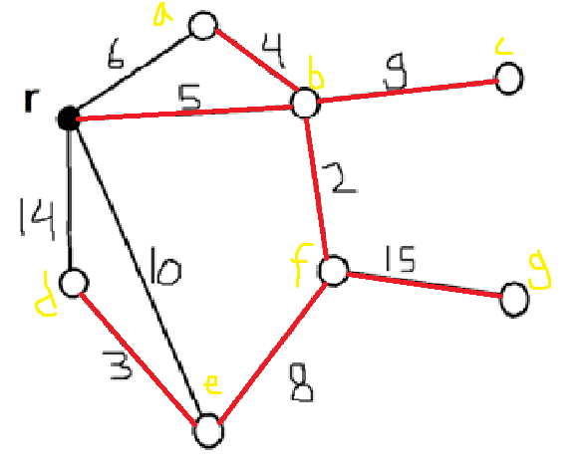

|  |  |  |
| --- | --- | --- |
| Steps | Edges | Weight |
| 1 | b-f | 2 |
| 2 | e-d | 3 |
| 3 | a-b | 4 |
| 4 | b-r | 5 |
| 5 | e-f | 8 |
| 6 | b-c | 9 |
| 7 | f-g | 15 |

Kuskral

